DS Assignment 7

NAME:TruptiLohakare
PRN:B24CE1065

/*Breadth First Search (BFS):
Application:Indexing web pages for search engines.
Example: A web crawler uses BFS to visit web pages systematically, starting from a seed URL and exploring links level by level. Nodes represent web pages. Edges represent hyperlinks. BFS ensures that pages at the same "depth" (distance from the starting page) are visited before moving to deeper levels. Write a program to simulate the indexing of web pages for a search engine using a Breadth-First Search (BFS) algorithm.*/

PROGRAM:
#include <iostream>
using namespace std;

#define MAX 10 // Maximum number of web pages

// BFS Function
void BFS(int graph[MAX][MAX], int start, int n) {
int visited[MAX] = {0}; // To mark visited pages
int queue[MAX]; // Simple array as queue
int front = 0, rear = 0;

// Start from the given node
visited[start] = 1;
queue[rear++] = start;

cout << "Order of indexing (web crawling): ";

while (front < rear) {
int current = queue[front++];
cout << "Page" << current << " ";

// Visit all connected pages (links)
for (int i = 0; i < n; i++) {
if (graph[current][i] == 1 && visited[i] == 0) {
visited[i] = 1;
queue[rear++] = i;
}
}
}
cout << endl;
}

int main() {
int n; // Number of web pages
int graph[MAX][MAX];

cout << "Enter number of web pages: ";
cin >> n;

cout << "\nEnter the link matrix (Adjacency Matrix):\n";
cout << "(1 means link exists, 0 means no link)\n";

for (int i = 0; i < n; i++) {
for (int j = 0; j < n; j++) {
cin >> graph[i][j];
}
}

int start;
cout << "\nEnter the starting page (0 to " << n - 1 << "): ";
cin >> start;

BFS(graph, start, n);

return 0;
}
OUTPUT:
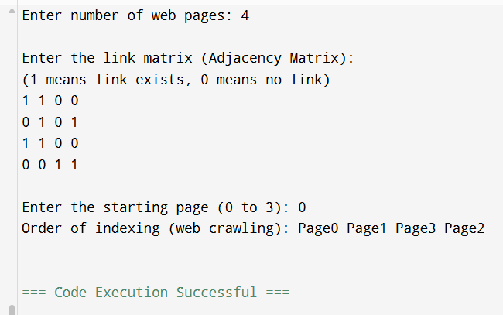
2nd PROGRAM:
#include <iostream>
using namespace std;

#define MAX 10 // maximum number of web pages

// Function for DFS traversal
void DFS(int graph[MAX][MAX], int visited[MAX], int start, int n) {
cout << "Indexing page " << start << endl; // simulate indexing
visited[start] = 1; // mark current page as visited

// explore all connected pages
for (int i = 0; i < n; i++) {
if (graph[start][i] == 1 && visited[i] == 0) {
DFS(graph, visited, i, n);
}
}
}

int main() {
int n; // number of web pages
cout << "Enter number of web pages: ";
cin >> n;

int graph[MAX][MAX];
int visited[MAX];

// initialize visited array
for (int i = 0; i < n; i++)
visited[i] = 0;

cout << "\nEnter adjacency matrix (use 1 if link exists, else 0):\n";
for (int i = 0; i < n; i++) {
for (int j = 0; j < n; j++) {
cin >> graph[i][j];
}
}

int start;
cout << "\nEnter starting page number (0 to " << n-1 << "): ";
cin >> start;

cout << "\nStarting Web Crawling using DFS...\n";
DFS(graph, visited, start, n);

cout << "\nAll reachable pages have been indexed!\n";
return 0;
}
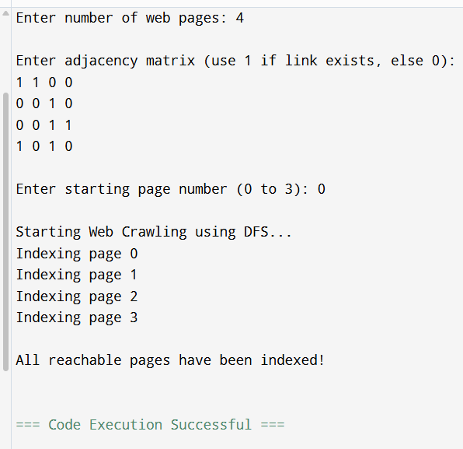
GITHUB:

